

Digital Logic Design Lab (EL-1005)
Submitted by
Imtishal Haq (i242556)
Laiba Basharat (i242041)
Maheen Irfan (i242519)

Bachelors of Artificial Intelligence
Date of Submission: May 9, 2025

Lab Instructor:
Mr. Talha Tariq

11: Dual Dice Roller for Board Games
Design a digital dice system with two independent 7-segment displays to simulate rolling two dice at once. It’s ideal for board game simulations. Each dice should function simultaneously, on pressing the button.
Functionality:
• Uses two 7-segment displays to show two dice outputs.
• Includes one push buttons, for both dice.
• Pressing a button causes both dice to roll (cycle numbers 1–6).
• Releasing the button stops the cycle and locks the result.
• Both dice can be rolled simultaneously.
• Uses counters and clock signals for rapid cycling.
• Implements basic logic for individual dice control.
Abstract
The purpose of this project is to develop a simple yet functional digital dice roller that simulates the rolling of two physical dice. Each dice is represented by a 7-segment display, and controlled individually by single push buttons. Upon pressing a button, a 555 timer in Astable mode generates pulses to a 7490 decade counter. This counter sends a Binary Coded Decimal (BCD) output to a 7447 BCD-to-7-segment decoder, which then drives a 7-segment display to visually represent the dice number. This system can be used as a replacement for physical dice in various digital board games or educational settings.

Introduction

Project Overview
This project is a digital system that replicates a pair of physical dice using electronics. Two 7-segment displays show the result of each roll, and each is independently controlled using separate buttons.

Objective
- Simulate rolling of two dice using digital electronics.
- A pushbuttons to control each dice.
- Implement independent functionality for each dice with real-time number cycling.

Importance of the Project
- Useful in board games where traditional dice may be unavailable.
- Enhances understanding of digital counters, clock signals, and display systems.
- Serves as a foundation for more advanced embedded game systems.

Design and Methodology

Design Process

The design methodology starts with defining the behavior of a dice roll, which is a random number generation between 1 and 6. In digital logic, we emulate randomness by cycling rapidly through numbers and then freezing the display when the user releases a button. The 555 timer acts as a pulse generator and feeds a clock signal into the 7490 counter. The output of the counter is masked to ignore invalid dice values (0, 7–9). To ensure accuracy, an AND gate controls the timer activation based on button press. The entire system is modular and expandable—more dice can be added using the same logic, and the circuit can be converted to microcontroller-based automation for further use in digital gaming environments.

Truth Table for Dice Values (1–6)
The following truth table shows dice values from 1 to 6 using BCD for the 7447 decoder:
Decimal | BCD (Q3 Q2 Q1 Q0)
1 | 0001
2 | 0010
3 | 0011
4 | 0100
5 | 0101
6 | 0110

Logic Design
- 555 Timer: Configured in Astable mode to generate clock pulses.
- 7447 BCD to 7-Segment Decoder: Converts counter output to display on 7-segment.
- 7490 Decade Counter: Rolls values from 0–9; output is masked to 1–6 using logic.
- AND Gate: Used to gate the clock signal to the counter only when the button is pressed.
- Push Buttons: Each button enables its respective AND gate to pass clock pulses.

Hardware Components
- 1 × 555 Timer ICs
- 2 × 7490 Decade Counters
- 2 × 7447 BCD to 7-Segment Decoders
- 2 × Common-Anode 7-Segment Displays
- 1 × Push Buttons
- AND Gates (e.g., 7408)
- Resistors, Capacitors, Breadboard (or simulation environment)

Circuit Diagram

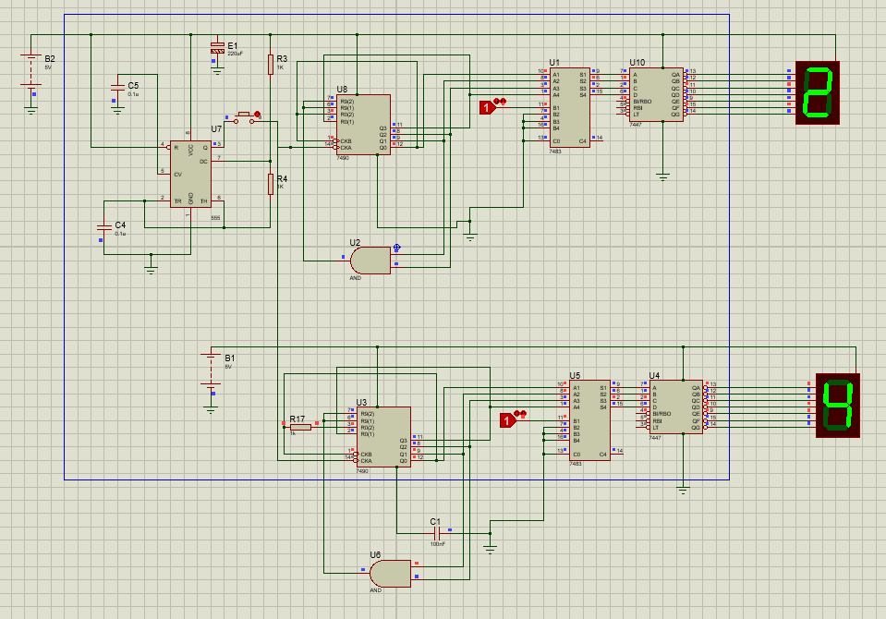

Software Tools
- Proteus Design Suite for circuit simulation

Simulation
The circuit was simulated in Proteus to verify real-time dice rolling behavior. Both dice operate independently with smooth transitions between numbers when buttons are held.

Testing and Results

Testing Procedure

Comprehensive testing was carried out in the Proteus environment. The button was tested to verify that it triggered both dice’s. Multiple rapid presses and releases were performed to simulate real-world usage and check the reliability of clock gating and output freezing. The simulation confirmed that the circuit correctly displays values between 1 to 6, and does not flicker or produce unintended values when the button is released. These outcomes validate the robustness and modular nature of the system.
- Press Button → Observe Dice 1 and 2 cycling numbers 1 to 6.
- Both the dice starts rolling and when stop the button both of them displays a random number ranging from 1-6.

Results
Test Case | Button Pressed | Dice 1 Value | Dice 2 Value | Result Behavior
1 | yes | 3 | - | Correct
2 | yes | - | 5 | Correct
3 | yes | 4 | 2 | Correct

Discussion of Results
The system worked as intended. Clock signals were correctly gated by button presses, allowing individual dice control. Filtering logic ensured only values 1–6 were shown.

Conclusion

Through the successful design and simulation of a dual dice roller circuit, this project demonstrates how basic digital logic components can be orchestrated to build interactive and practical applications. The modular architecture enables future improvements such as sound integration, LED animations, or game scoring modules. Educationally, the project solidifies understanding of digital counters, clock signals, and display interfacing—core concepts in digital electronics. With further enhancements, this circuit can evolve into a complete game controller interface or be embedded into a digital learning kit for logic circuit learners.

